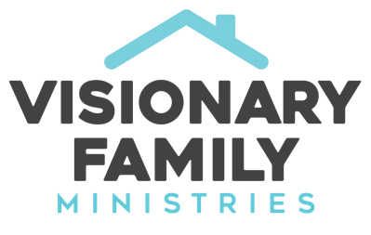
Your Family and God's Plan for the World
Dr. Rob Rienow

I. Introduction

II. Passing Faith Through the Generations

III. The Family and the Gospel

A. The first commandment – Genesis 1:28

B. God saves a family – Genesis 6:5ff

C. Why God chose Abraham – Genesis 18:18-19

D. The first commandment for human relationships – Ex. 20:12

E. The Great Commandment and the home – Deut. 6:5-7

F. The final words of the Old Testament – Malachi 4:4-6

G. The "first words" of the New Testament – Luke 1:16-17

H. Jesus went against the popular and religious culture of his day and prioritized children – Mark 10:13-16

I. The Great Commission echoes the First Commandment – Matt 28:18-20

J. The NT Church launches with generational vision – Acts 2:38-39

K. No greater joy… - 3 John 1:4

IV. Conclusion and prayer



